Network Traffic Analysis Report – Task 3
Tools Used: Wireshark v4.4.4, Kali Linux (Kernel 6.12.13)
“Network Interface: eth0

1. Executive Summary
This report analyzes network traffic captured during a standard browsing session on a Kali Linux system¹. The analysis covers the lifecycle of network communication, starting from domain resolution (DNS) and connection establishment (TCP Handshake) to data transmission (HTTP/HTTPS)²²².

2. DNS Query Analysis
The capture begins with DNS queries to resolve hostnames into IP addresses, facilitating connection to web services³.
- Observed Domains: Resolution requests were identified for contile.services.mozilla.com and push.services.mozilla.com⁴⁴⁴.
- Infrastructure Traffic: Queries were also observed for certificate validation services (OCSP) such as o.pki.goog and content delivery networks like content-signature-2.cdn.mozilla.net⁵⁵⁵.
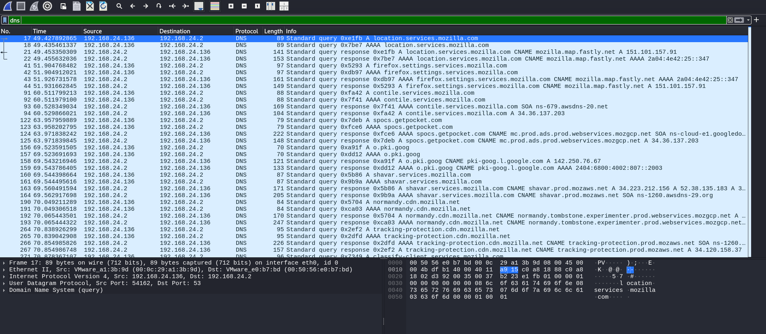
DNS Filter Applied

3. TCP Three-Way Handshake
A successful TCP Three-Way Handshake was identified, confirming a reliable connection between the client and the remote servers⁶.
Step | Packet Flag | Action Description
1 | [SYN] | Client initiates a connection request to the server.
2 | [SYN, ACK] | Server acknowledges and agrees to the connection.
3 | [ACK] | Client sends final acknowledgment; connection is established.

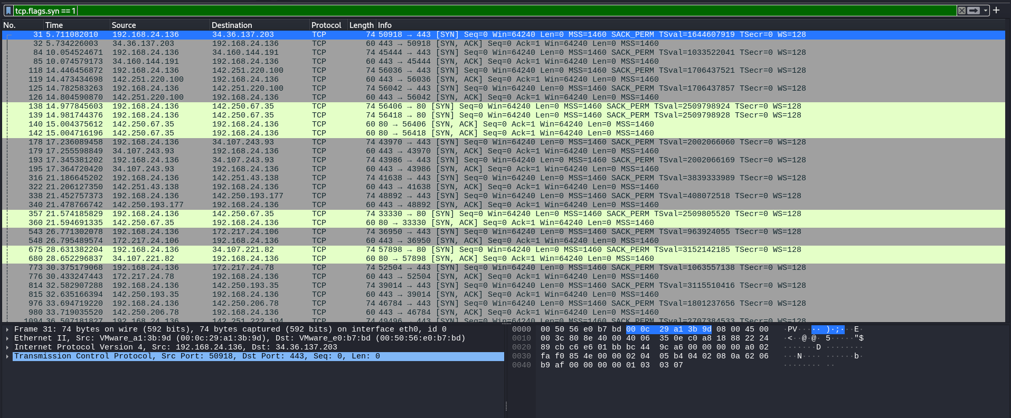
TCP Three-Way Handshake

4. Protocol Comparison: HTTP vs. HTTPS (TLS)
The analysis demonstrates the critical difference between plaintext and encrypted communications⁷⁷⁷⁷.

A. Plaintext Communication (HTTP)
In instances where traffic was not encrypted, sensitive metadata and request details were visible⁸⁸.
- Target Host: o.pki.goog ⁹⁹
- User-Agent: Mozilla/5.0 (X11; Linux x86_64; rv:128.0) Gecko/20100101 Firefox/128.0 ¹⁰¹⁰
- Data Visibility: Request methods (e.g., POST /we2) and content types (application/ocsp-request) were fully readable in the packet bytes¹¹¹¹.

B. Secure Communication (HTTPS/TLS)
Secure traffic was protected using TLS 1.3/TLS 1.2 with certificates issued by authorities like Let's Encrypt and Internet Security Research Group¹².
- Encryption: Following the TLS handshake, the protocol shifts to "Encrypted Application Data"¹³¹³.
- Effect: The payload consists of randomized hexadecimal strings, ensuring that actual web content (URLs, forms, and responses) cannot be intercepted by unauthorized parties¹⁴¹⁴.
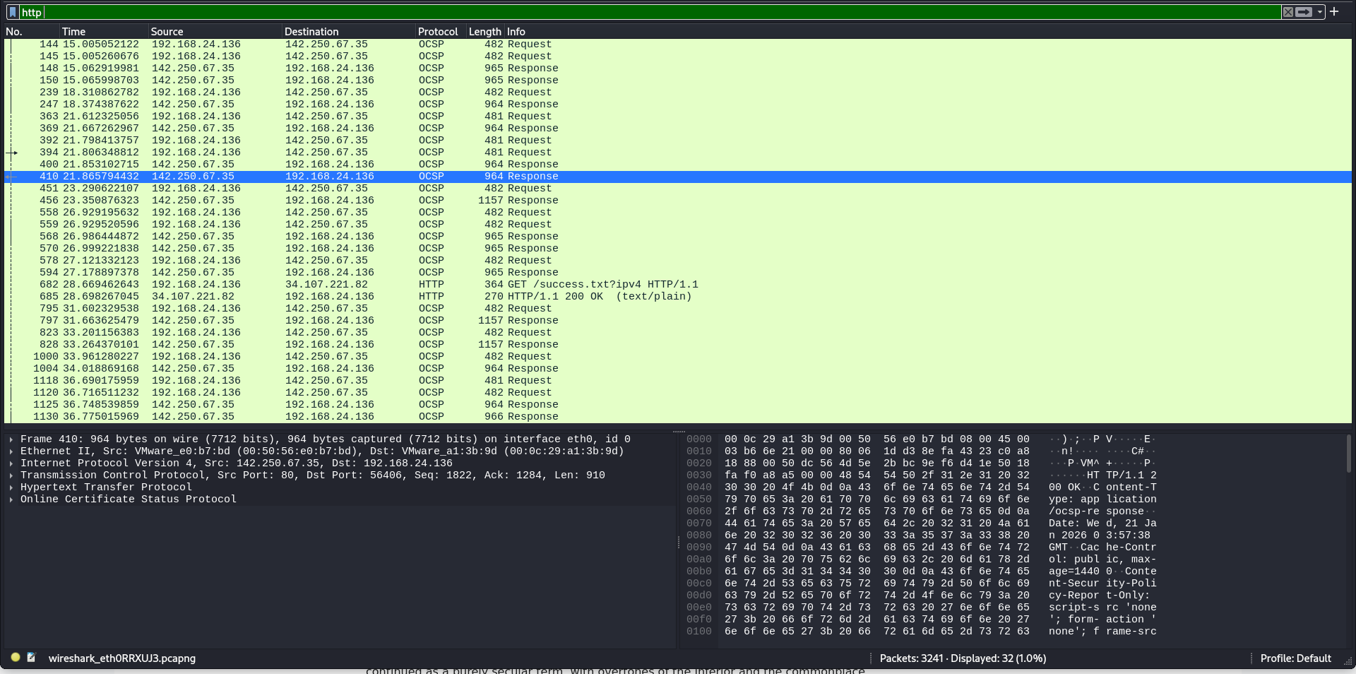
HTTP → readable
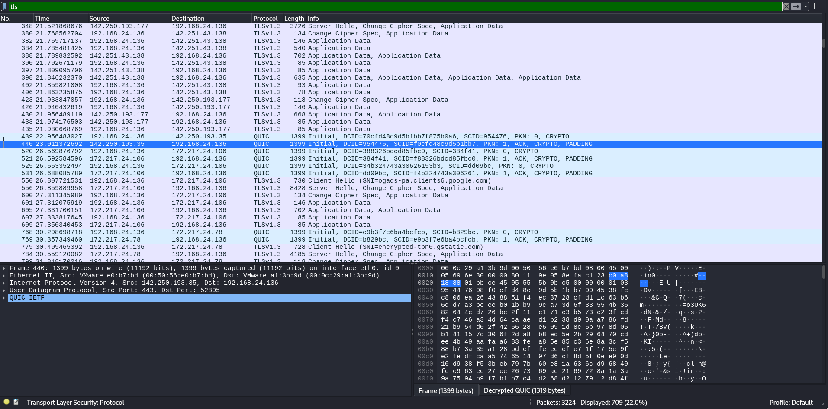
TLS → encrypted

5. Identified Traffic Summary
The following table summarizes key network participants identified in the task3_kali_capture.pcapng file:
Service Provider | Common Domain | Protocol | Purpose
Mozilla | contile.services.mozilla.com | HTTPS (TLS) | Browser configuration/services ¹⁵
Google/PKI | o.pki.goog | HTTP (OCSP) | Digital certificate status check ¹⁶¹⁶
Google Fonts | fonts.gstatic.com | HTTPS (TLS) | Web resource loading ¹⁷
Wikimedia | en.wikipedia.org | HTTPS (TLS) | User browsing activity ¹⁸

6. Conclusion
The captured traffic successfully demonstrates secure communication practices. While background maintenance traffic (like OCSP) may occur over HTTP, all primary browsing data is encapsulated within TLS tunnels¹⁹¹⁹¹⁹¹⁹. This confirms that the browsing session on Kali Linux was protected against basic packet sniffing for sensitive application data.

